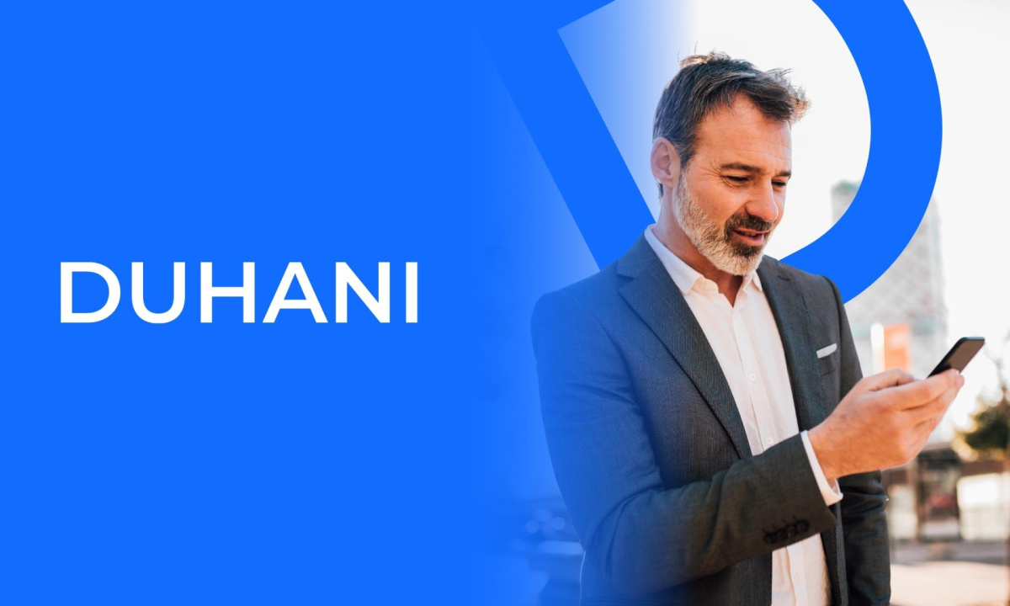

## **Duhani Capital Announces Enhanced Trading Solutions and Commitment to Client Success**

**Durres, Albania, Date, Financewire**

[Duhani Capital,](https://duhanicapital.com/) a leading online trading platform, has announced a series of strategic initiatives and platform enhancements designed to empower traders worldwide. With a steadfast commitment to security, transparency, and excellence, Duhani Capital continues to innovate, providing clients with unparalleled trading experiences

**Introducing Enhanced Trading Platforms**

To cater to the diverse needs of modern traders, Duhani Capital has upgraded its suite of trading platforms:

* **WebTrader**: This browser-based platform requires no installation, allowing traders to access global markets seamlessly from any device. With an intuitive interface and advanced trading tools, WebTrader ensures efficient trade execution and management.
* **MetaTrader 5 (MT5)**: Recognized globally for its robust features, MT5 is now fully integrated with Duhani Capital. Traders can benefit from comprehensive market analysis tools, algorithmic trading capabilities, and a user-friendly interface. Detailed guides are available to assist clients in maximizing the platform's potential.

**Diverse Account Types Tailored for Every Trader**

Understanding that each trader has unique requirements, Duhani Capital offers a range of account types:

* **Micro Account**: Suitable for beginners, this account features spreads as low as 1.2 pips, no commission, swap-free options, and no minimum deposit requirement. It also offers leverage up to 1:1000 for Forex trading.
* **Standard Account**: Designed for intermediate traders, it provides similar benefits to the Micro Account, ensuring a seamless transition as traders gain experience.
* **Professional Account**: For seasoned traders, this account offers spreads starting at 0.6 pips, no commission, swap-free options, and a minimum deposit of $1,000. It also includes leverage up to 1:1000 for Forex trading.

Each account type is crafted to align with traders' goals, ensuring flexibility and optimal trading conditions.

**Commitment to Secure and Regulated Trading**

Duhani Capital's partnership with Financial Master Management Ltd. and possession of a Master Financial Dealer License underscores its dedication to providing a secure and compliant trading environment. Clients can engage in trading within a framework designed to align with regulatory standards for security and compliance.

**Stable Spreads and Cost-Effective Trading**

Duhani Capital provides stable spreads, enabling more predictable performance. The platform also eliminates hidden fees, including zero overnight and administrative charges, allowing traders to maximize their returns without unexpected costs.

**User-Friendly Interface and Advanced Tools**

The platform's intuitive design ensures that both novice and experienced traders can navigate the system with ease. Advanced trading tools, real-time market data, and customizable interfaces empower clients to make informed decisions swiftly.

**Educational Resources and Support**

Duhani Capital provides educational resources such as tutorials, webinars, and market analyses to support informed trading decisions. A support team is available 24/5 to assist with inquiries, offering guidance on market trends and strategies.

**Global Market Access**

Clients of Duhani Capital can access a wide range of financial instruments, including Forex, commodities, indices, and cryptocurrencies. This extensive market access allows traders to diversify their portfolios and capitalize on global market opportunities.

**Looking Ahead**

Duhani Capital remains dedicated to continuous improvement and innovation. Future plans include the introduction of new trading instruments, enhanced analytical tools, and expanded educational content to further support traders in achieving their financial goals.

**About Duhani Capital: https://duhanicapital.com/**

[Duhani Capital](https://duhanicapital.com/) is a premier online trading platform offering clients access to global financial markets. With a focus on security, transparency, and excellence, the company provides cutting-edge trading solutions tailored to meet the diverse needs of its clientele. Through continuous innovation and a client-centric approach, Duhani Capital empowers traders to navigate the financial markets with confidence.

https://duhanicapital.com/

##### **Contact Information**

**Ali Yılmaz**  
**CEO of Duhani Capital**  
[ali.yilmaz@duhanicapital.com](mailto:ali.yilmaz@duhanicapital.com)

**https://duhanicapital.com/**